**Chapter 24. Gauss’s Law**

St. ID: , Name:

1. A vertical electric field of magnitude 2.00 **×** 104 N/C exists above the Earth’s surface on a day when a thunderstorm is brewing. A car with a rectangular size of 6.00 m by 3.00 m is traveling along a dry gravel roadway sloping downward at 10.0°. Determine the electric flux through the bottom of the car.

Ans:

The electric flux through the bottom of the car is given by



1. 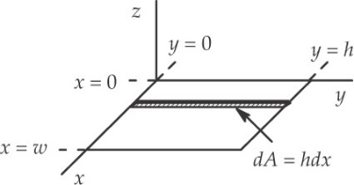A nonuniform electric field is given by the expression where *a, b,* and *c* are constants. Determine the electric flux through a rectangular surface in the *xy* plane, extending from *x* **=** 0 to *x* **=** *ω* and from *y* **=** 0 to *y = h.*

Ans:

We are given an electric field in the general form

 **ans. Fig. P23.12**

In the *xy* plane, *z* = 0 so that the electric field reduces to



1. ****Find the net electric flux through the spherical closed surface shown in Figure P24.8. The two charges on the right are inside the spherical surface.

Ans:

The gaussian surface encloses the +1.00-nC and –3.00-nC charges, but not the +2.00-nC charge. The electric flux is therefore **Figure P24.8**



1. (a) Find the net electric flux through the cube shown in Figure P24.15. (b) Can you use Gauss’s law to find the electric field on the surface of this cube? Explain.

****Ans:

1. The gaussian surface encloses a charge of +3.00 nC.



**Figure P24.15**

1. 